Special Lecture

特別講義のご案内
「Critical Metals: Changes in Demand and Mining」
December 22 (WED), 2021 10:30-12:00, 13:00-14:30
Rm. 322, W2
W2号館3階322室

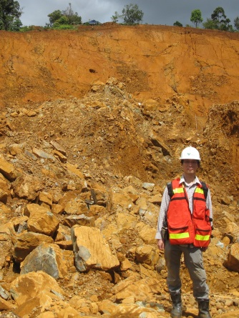
Lecturer/講師：
Dr. SANEMATSU Kenzo/実松 健造 博士

Research Institute for Geo-Resources and Environment, National Institute of Advanced Industrial Science and Technology (AIST)
(Visiting Professor, Center for Research and Education of Environmental Technology, Faculty of Engineering）
国立研究開発法人産業技術総合研究所地圏資源環境研究部門
（工学研究院附属環境工学研究教育センター 客員教授）

【Contact】/【お問い合わせ】
YONEZU Kotaro (yone@mine.kyushu-u.ac.jp)
Department of Earth Resources Engineering, Faculty of Engineering
工学研究院地球資源システム工学部門・米津 幸太郎

